Hands-on: 1. Different types of implementing JS code

<!Doctype html>

<head>

    <!--insert a external -->

    <script src="external.js">

    </script>

<!--Insert a script in head-->

<script>

    document.write("head element");

</script>

</head>

<body>

    <!-- Insert a script in body-->

    <script>

        document.write("body element");

    </script>

</body>

</html>

Output:

head element

body element

Hands-on 2: JS CONSOLE

<!Doctype html>

<head>

</head>

<body>

   <script>

        var a=10;

        console.log(10);

    </script>

</body>

</html>

Output:

10

Hands-on 3: JS DOM

Code for: Using HTML element id to find the DOM HTML element

<!DOCTYPE html>

<html>

<body>

    <h2>EDUNET FOUNDATION</h2>

    <!-- Finding the HTML Elements by their Id in DOM -->

    <p id="intro">A Computer Science portal for EDUNET FOUNDATION.</p>

    <p>This example illustrates the <b>getElementById</b> method.</p>

    <p id="demo"></p>

    <script>

        const element = document.getElementById("intro");

        document.getElementById("demo").innerHTML =

        "EDUNET FOUNDATION introduction is: " + element.innerHTML;

    </script>

</body>

</html>

OUTPUT:

**EDUNET FOUNDATION**

A Computer Science portal for EDUNET FOUNDATION.

This example illustrates the **getElementById** method.

EDUNET FOUNDATION introduction is: A Computer Science portal for EDUNET FOUNDATION.

Hands-on 4: JS DOM

Code for: Change the color of "heading ID selector”

<!DOCTYPE html>

<html>

<body>

<h1 id="heading">The Element Object</h1>

<h2>The style Property</h2>

<script>

document.getElementById("heading").style.color = "red";

</script>

</body>

</html>

OUTPUT:

# **The Element Object**

## The style Property

Hands-on 5: JS DOM

Change the text of the first child element with class="example" in a <div> element:

<!DOCTYPE html>

<html>

<head>

<style>

#myDIV {

  border: 1px solid black;

}

</style>

</head>

<body>

<div id="myDIV">

  <h2 class="example">A heading with class="example" in div</h2>

  <p class="example">A paragraph with class="example" in div.</p>

</div>

<p>Click the button to change the text of the first element with class="example" in div.</p>

<button onclick="myFunction()">Try it</button>

<script>

function myFunction() {

  var x = document.getElementById("myDIV");

  x.querySelector(".example").innerHTML = "Hello World!";

}

</script>

</body>

</html>

OUTPUT:

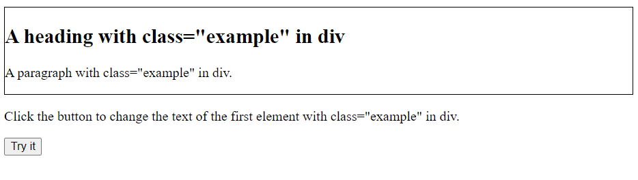

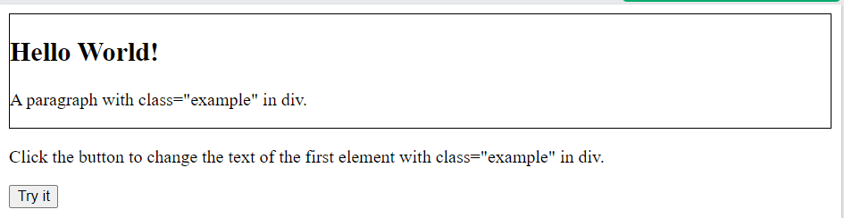

Hands-on 6: Node

Code for : Append an item to a list:

<!DOCTYPE html>

<html>

<body>

<h1>The Element Object</h1>

<h2>The appendChild() Method</h2>

<ul id="myList">

  <li>Coffee</li>

  <li>Tea</li>

</ul>

<p>Click "Append" to append an item to the end of the list:</p>

<button onclick="myFunction()">Append</button>

<script>

function myFunction() {

// Create an "li" node:

const node = document.createElement("li");

// Create a text node:

const textnode = document.createTextNode("Water");

// Append the text node to the "li" node:

node.appendChild(textnode);

// Append the "li" node to the list:

document.getElementById("myList").appendChild(node);

}

</script>

</body>

</html>

OUTPUT:

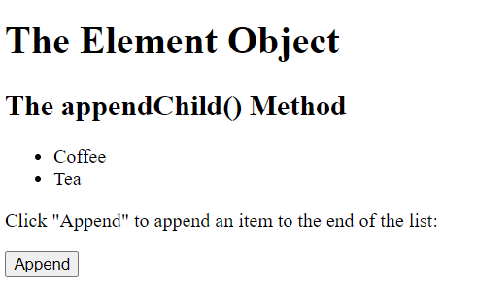

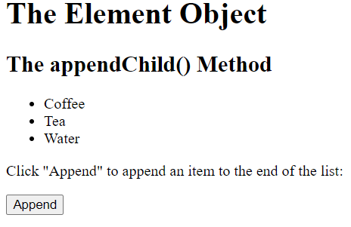

Hands-on 7: Node

Code for: Get the HTML content of the last child of a <ul> element:

<!DOCTYPE html>

<html>

<body>

<h1>The Element Object</h1>

<h2>The lastElementChild Property</h2>

<ul id="myList">

  <li>Coffee</li>

  <li>Tea</li>

</ul>

<p>The HTML content of "myLIST"s last child element is:</p>

<p id="demo"></p>

<script>

const element = document.getElementById("myList")

document.getElementById("demo").innerHTML = element.lastElementChild.innerHTML;

</script>

</body>

</html>

OUTPUT:

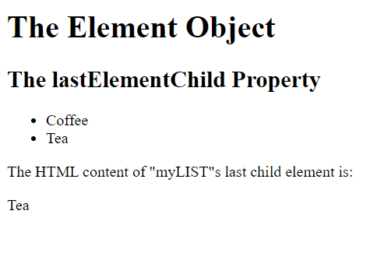

Hands-on: 8 JS Events

Code for: Display a message in the alert box when the button is clicked

<!doctype html>

<html>

<head>

<script>

function hiThere() {

alert('Hi there!');

}

</script>

</head>

<body>

<button type="button"

onclick="hiThere()"

style="margin-left: 50%;">

Click me event

</button>

</body>

</html>

OUTPUT:



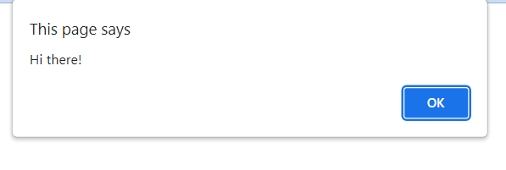

Hands-on: 8 JS Events

Code for : Box vanish when the mouse will be hovered on it

<!doctype html>

<html>

<head>

<script>

function hov() {

var e=document.getElementById('hover');

e.style.display='none';

}

</script>

</head>

<body>

<div id="hover"

onmouseover="hov()"

style="background-color:green;

height:200px;

width:200px;">

</div>

</body>

</html>

Output:



Hands-on: 9 JS Events

Code for: **on change event**

<!doctype html>

<html>

<head></head>

<body>

    <input onchange="alert(this.value)"

        type="number"

        style="margin-left: 45%;">

</body>

</html>

OUTPUT:



Hands-on: 10 JS Animation

<!DOCTYPE HTML>

<html>

<head>

  <style>

    #train {

      position: relative;

      cursor: pointer;

    }

  </style>

</head>

<body>

  <img id="train" src="https://js.cx/clipart/train.gif">

  <script>

    train.onclick = function() {

      let start = Date.now();

      let timer = setInterval(function() {

        let timePassed = Date.now() - start;

        train.style.left = timePassed / 5 + 'px';

        if (timePassed > 2000) clearInterval(timer);

      }, 20);

    }

  </script>

</body>

</html>

OUTPUT:

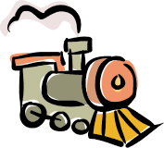



Hands-on: 11 JS Cookies

<html>

   <head>

      <script type = "text/javascript">

         <!--

            function WriteCookie()

            {

               if( document.myform.customer.value == "" ) {

                  alert("Enter some value!");

                  return;

               }

               cookievalue = escape(document.myform.customer.value) + ";";

               document.cookie="name=" + cookievalue;

               document.write ("Setting Cookies : " + "name=" + cookievalue );

            }

         //-->

      </script>

   </head>

   <body>

    <form name = "myform" action = "">

         Enter name: <input type = "text" name = "customer"/>

         <input type = "button" value = "Set Cookie" onclick = "WriteCookie();"/>

      </form>

   </body>

</html>

OUTPUT:







Hands-on: 12 JS Session

<!DOCTYPE html>

<html>

<body>

<h1>The Window Object</h1>

<h2>The sessionStorage Object</h2>

<p>A Counter:</p>

<p id="demo">0</p>

<p><button onclick="clickCounter()" type="button">Count</button></p>

<p>Click to see the counter increase.</p>

<p>Close the browser tab (or window), and try again, and the counter is reset.</p>

<script>

function clickCounter() {

if (sessionStorage.clickcount) {

sessionStorage.clickcount = Number(sessionStorage.clickcount) + 1;

} else {

sessionStorage.clickcount = 1;

}

document.getElementById("demo").innerHTML = sessionStorage.clickcount;

}

</script>

</body>

</html>

OUTPUT:

